TASK | Cleaning paintwork and overspray
LOCATION OF USE | Workshop |  | Assessment  No |  | 013
PRODUCT NAME | Farecla G3 Paste Compound
DESCRIPTION OF SUBSTANCE | Polish and wax blend. Surface finishing medium
MANUFACTURER | Farecla Products Ltd
MANUFACTURERS CONTACT | Broadmeads  Ware  Hertfordshire  SG12 9HS  Tel: +44 (0)1920 465041  Fax: +44 (0)1920 466557  Email: technical@farecla.com
ASSESSOR | Martin Monaghan CMIOSH |  | Date |  | 04 12 25
TITLE | Health and Safety Consultant |  | Review by |  | 04 12 27
Personnel Performing Task  (Please list below)  Technicians/ Fitters/ Workshop Operatives |  | Time Spent  (Minutes/day)  As and when required, amounting to a few minutes per day | Training Given 
 |  |  | Yes

MSDS Revision Date | Hazard Statement
30/06/2015 | H317 May cause an allergic skin reaction  H373 May cause damage to organs  H412 Harmful to aquatic life with lasting effects

Assessment to be conducted in Association with Hazard Data Sheets, a full current copy of which must be attached to this assessment.

Please denote the hazardous properties of the substances used in the task with a 

NEW INTERNATIONAL GLOBALLY HARMONISED HAZARD SYMBOLS
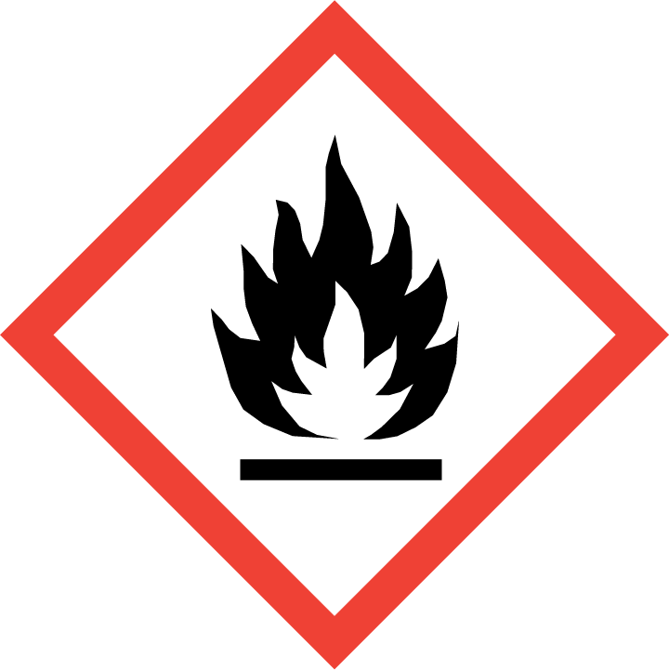 | 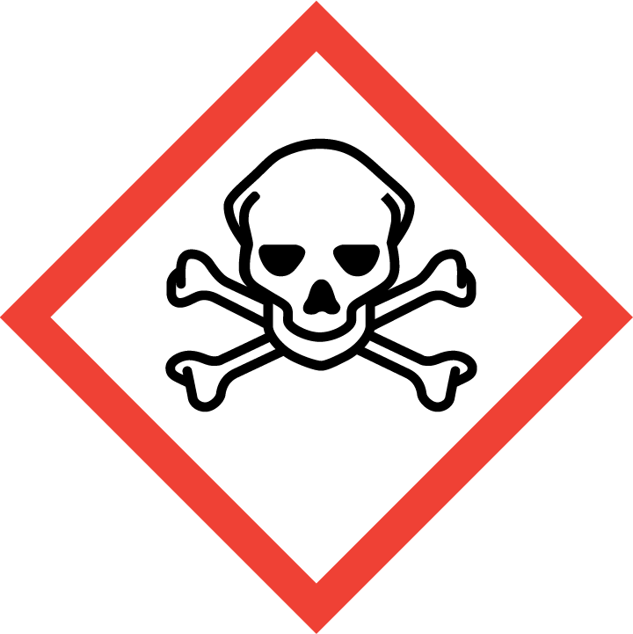 | 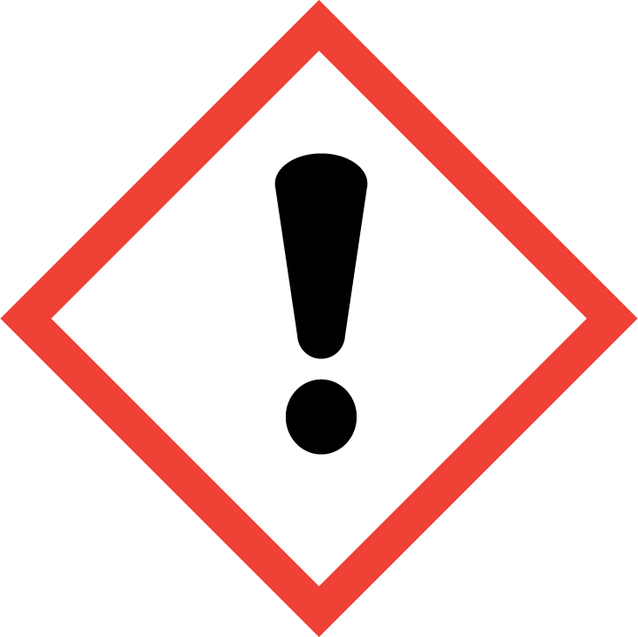 | 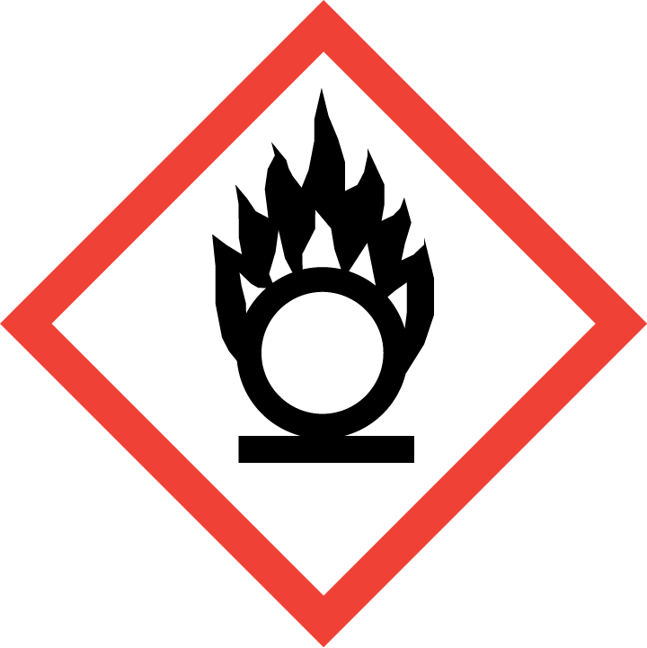 | 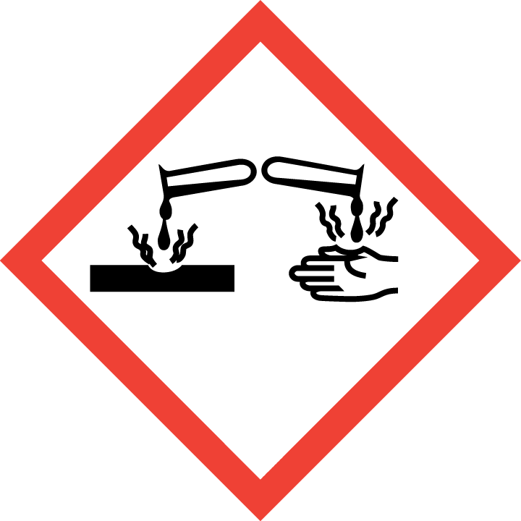 | 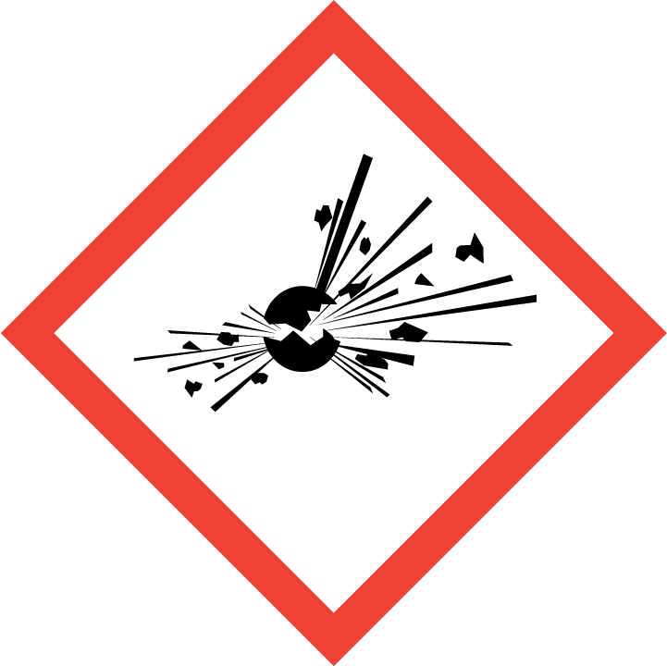 | 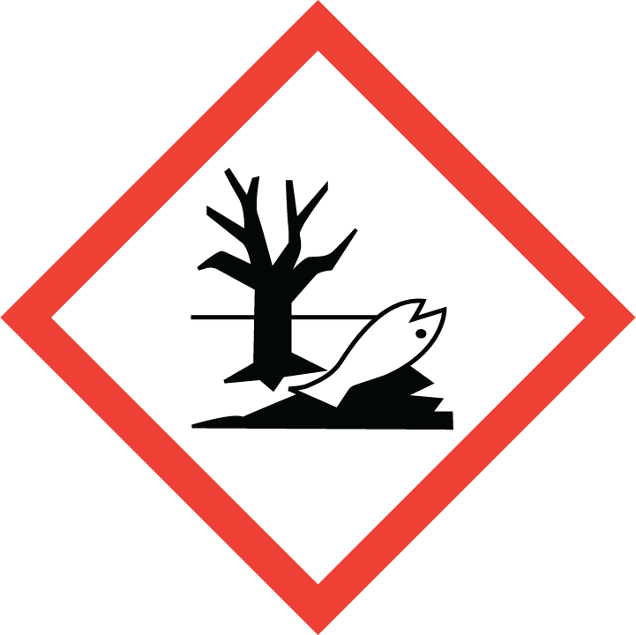 | 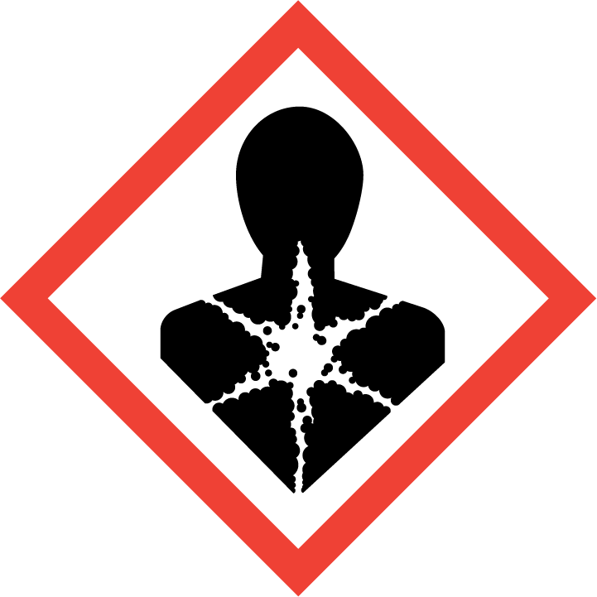
Flammable | Toxic | Harmful | Oxidising | Corrosive | Explosive | Harmful to the environment | Health Hazards i.e. respiratory sensitisation or carcinogenicity
 |  |  |  |  |  |  | 

SMOKING, EATING AND DRINKING ARE PROHIBITED IN THE WORK AREAS.
Information, Instruction and Training must be provided to all users. Young Persons, New or Expectant Mothers and other vulnerable groups must not use or be exposed to this product.

WORKPLACE EXPOSURE LIMITS (WEL’s)
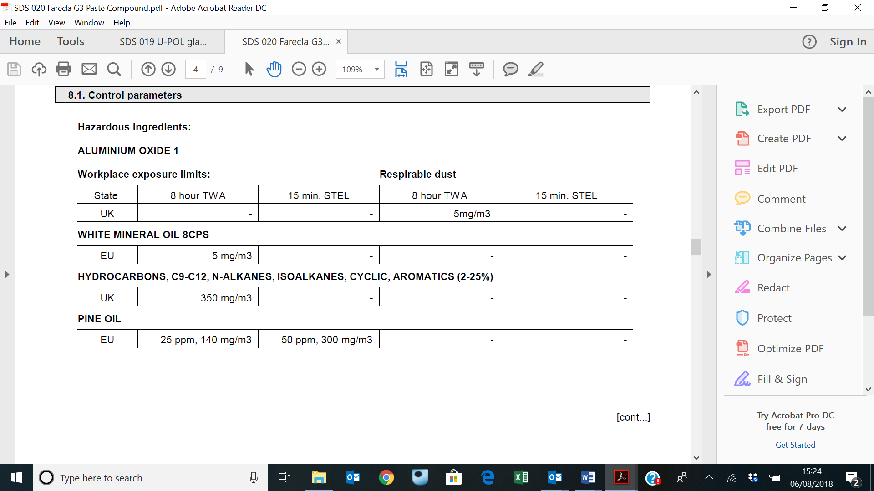

IMPORTANT!
Refer to Workplace Exposure Levels information provided in the Manufacturers Safety Data and revise control measures if exposure levels likely to be reached.

ROUTE OF EXPOSURE
Skin |  | Eyes |  | Inhalation | 
Ingestion |  | Cuts/abrasions |  | Systemic

PERSONS AT RISK
User of product |  | Co workers |  | Members of the public

ROUTE OF EXPOSURE |   FIRST AID MEASURES
Eyes | Bathe the eye with running water for 15 minutes.
Skin | Remove all contaminated clothes and footwear immediately unless stuck to skin. Wash immediately with plenty of soap and water. Consult a doctor
Inhalation | Remove casualty from exposure ensuring one’s own safety whilst doing so. Consult a doctor.
Ingestion | Wash out mouth with water. Consult a doctor
In all cases of doubt, or if symptoms persist seek medical attention. Never give anything by mouth to an unconscious person. If unconscious, place in recovery position and seek medical advice.

PERSONAL PROTECTIVE EQUIPMENT
 |  | 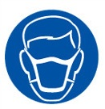 |  | 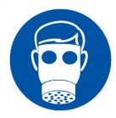 |  | 
YES | YES | YES/NO |  | YES/NO | YES | YES/NO
 |  |  |  |  | 
YES | YES |  |  |  | YES

HANDLING | STORAGE | TRANSPORT | DISPOSAL
Avoid direct contact with the substance. Prevent mixing with air or creating dust. | Store in cool, well -ventilated area. Keep container tightly closed. | This product does not require a classification for transport. | Dispose of packaging with an appropriate licensed waste service

REQUIRED CONTROL MEASURES
- Users to avoid contact with skin and eyes, and inhalation of vapours/ spray or mist arising from the application of this preparation – Use PPE.
- Only opened solvent containers should be kept at the bench.
- When not in use, opened solvent containers should be kept in the flammables cupboards, under the work benches.
- Wash contaminated clothing before reuse. Wash hands after contact. Use appropriate hand lotion to prevent defatting and cracking of skin. Promptly remove non-impervious clothing that becomes wet or contaminated. When using, do not eat, drink or smoke.
- Ensure adequate welfare and washing facilities available and provide users with barrier and restorative creams. Take good hygiene measures.
- Ensure operatives are made aware of and understand the purpose of this assessment and SDS, plus any health implications of using the product.
- Ensure COSHH assessments with accompanying SDS are made available for all employees and users and for inspection and emergency purpose.
- Wash promptly if skin becomes contaminated. Wash hands at the end of each work shift and before eating, smoking and using the toilet.
- Ensure there is sufficient ventilation within the working area
- Ensure eyewash is to hand.

FIRE PRECAUTIONS
EXTINGUISHING MEDIA
Suitable extinguishing media for the surrounding fire should be used.

UNUSUAL FIRE & EXPLOSION HAZARDS
In combustion emits toxic fumes.

ADVICE TO FIRE FIGHTERS
Wear self-contained breathing apparatus. Wear protective clothing to prevent contact with skin and eyes.

ACCIDENTAL RELEASE/SPILLAGE PROCEDURES
Do not attempt to take action without suitable protective equipment. Do not create dust. Do not discharge into drains or rivers. Transfer to an appropriate labelled container. Dispose of the container appropriately.

MONITORING REQUIREMENTS AND HEALTH SURVEILLANCE
Health surveillance is not in place for workers exposed to this product.

